Stuff to know about Brittany’s Tutorials

- Whenever there are colored ovals on one of the pictures, the colors of the ovals correspond to the color of the type when I tell you click on something. Except for red. Red just means it’s important.
- Sometimes I’ll run out of colors and decide to use arrows. Those are self-explanatory.
- Notes can be helpful to, so don’t skip over them.
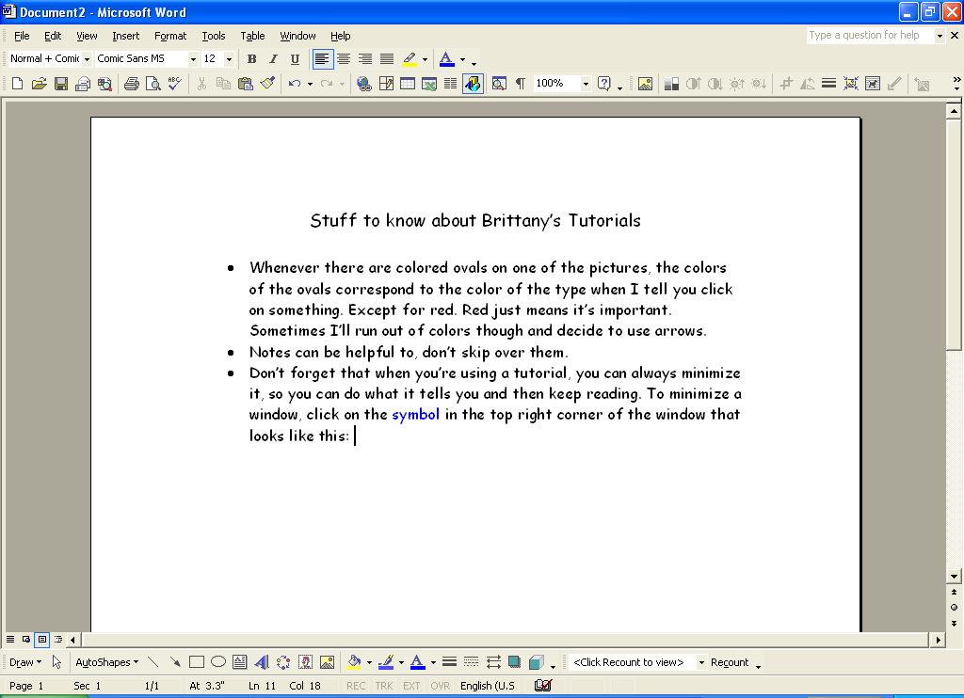
- Don’t forget that when you’re using a tutorial, you can always minimize it, so you can do what it tells you and then keep reading. To minimize a window, click on the symbol in the top right corner of the window that looks like this:

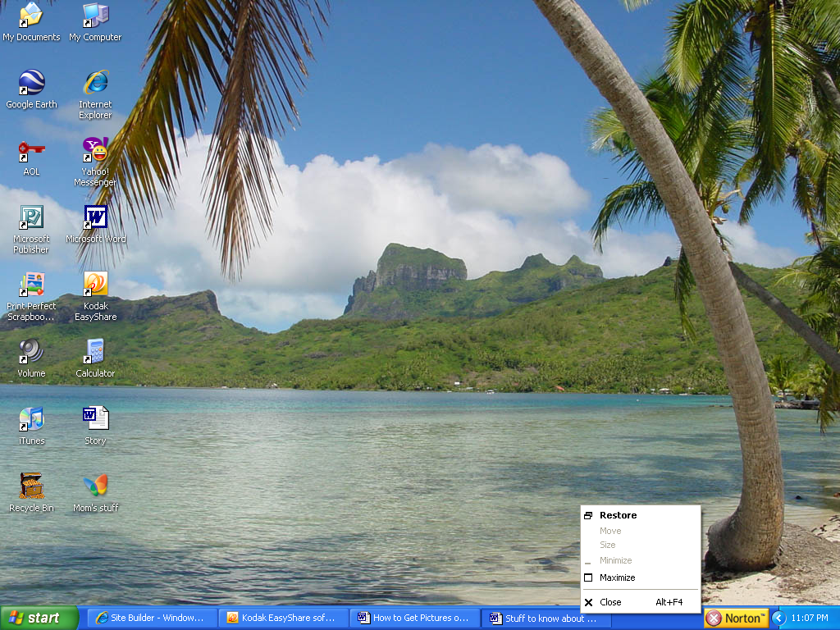
- To un-minimize a window (or maximize it), just click on the bar at the bottom of your screen. Or, you can right click on the bar, and select maximize. You can also close a window this way. Just click on close instead of maximize. It does the same thing as clicking on the little red “X” in the corner which I know you already know how to do.

