How to Get Pictures off Your Camera
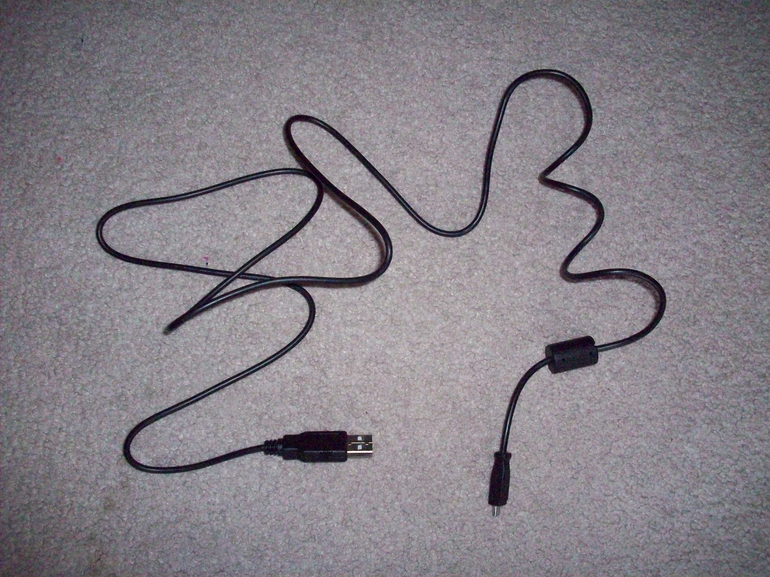
By: Brittany Clark

– Find the cord that looks like this:
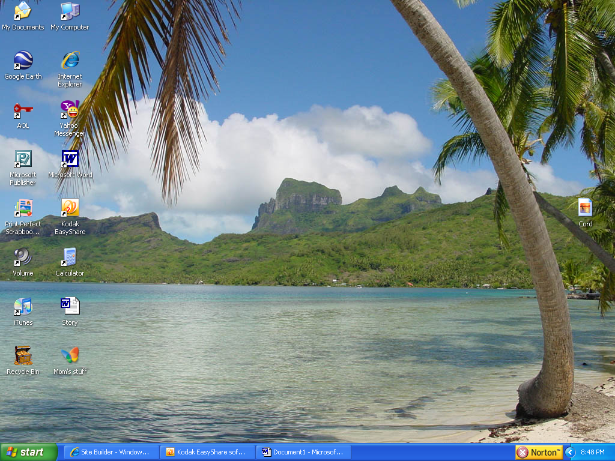
Step 2 – (these next three steps must be done in order, or it won’t work) Open the Kodak Easyshare software (double click on this):

Step 3 – Plug in your camera. Big end in the computer, small end in the camera.

Step 4 – Press the on/off button on your camera. The green light on the camera that turned on when you plugged it in should now be blinking. A window will come up that looks like this:
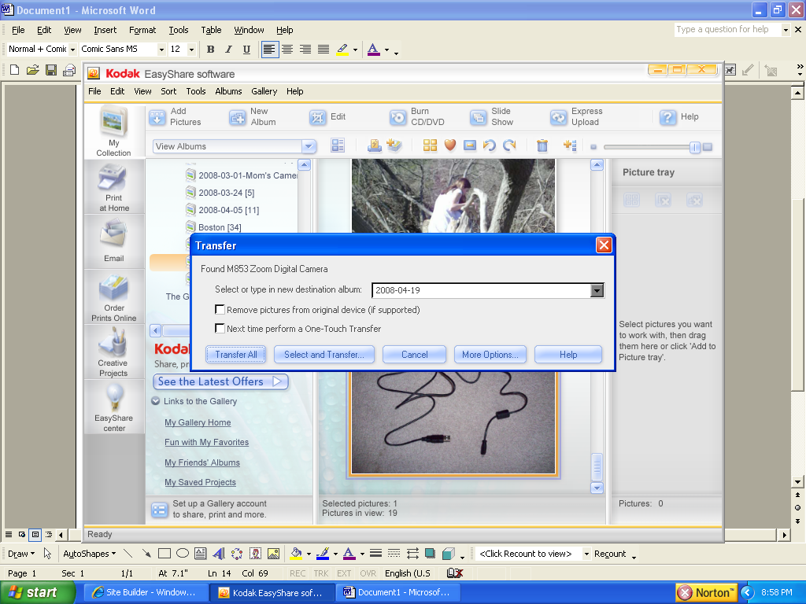
The only difference between our windows is yours will show a different date in the white box, and it won’t say “M853 Zoom Digital Camera” if you have a different model camera.

If you just want to transfer all your pictures, go straight to step 6½. If you want to be picky and only transfer some, go on to step 5.

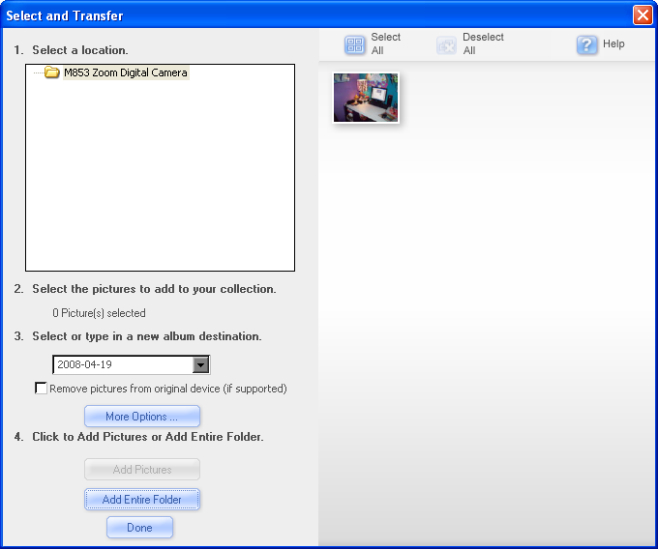
Step 5 – Click on Select and Transfer... , and a window will appear that looks like this:

Step 6 – Click on all the pictures that you want to be transferred, and the pictures that are going to transfer will be highlighted in orange. If you accidentally click on one that you didn’t want to transfer, just click on it again. The orange highlight will go away. Before you finish, if you want those pictures to be deleted from you camera too, put a checkmark in the little white box where it says Remove pictures from original device (if supported).

When you’re done, click on Done. The box will disappear and your pictures will start transferring. If you by chance click on Add Pictures, no worries, they’ll still start transferring, but you’ll have to close the window your self (when they’re done of course).

Step 6½ - (Skip this if you decided to be picky, but don’t skip the notes part after it) If you want the pictures to be deleted from you camera too, put a checkmark in the little white box where it says Remove pictures from original device (if supported). Click on Transfer All. Your pictures will start transferring.

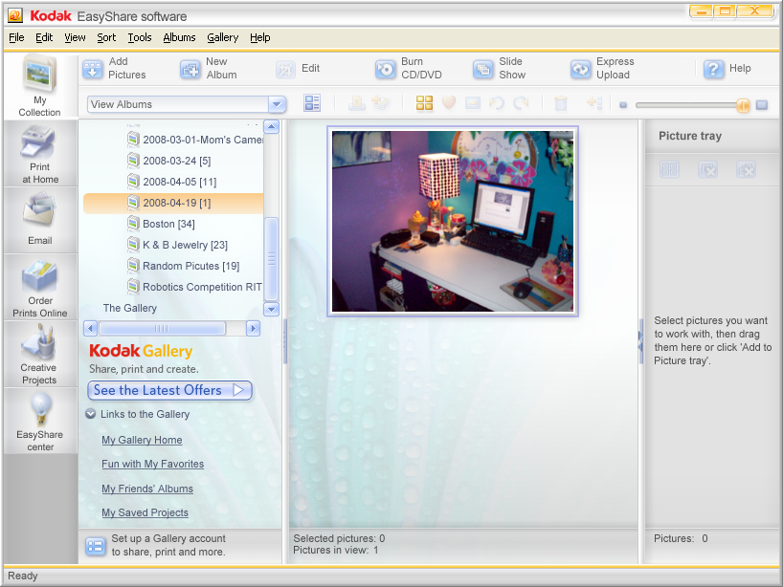
Notes – There’s a lot you can do once the pictures are in there. If you want to see them more closely, you can use the scroll bar in the upper right corner. Or, just double click on the pictures themselves to make them really, really big. This will open them in a new window. You can edit them too. There’s all kinds of cool effects in the Easyshare software, but if you really want to know more about them I’ll put that in another tutorial. For now, we’re just getting them in there. Go on to step 7 if you want to put them on your desktop so you can put them in E-mails.

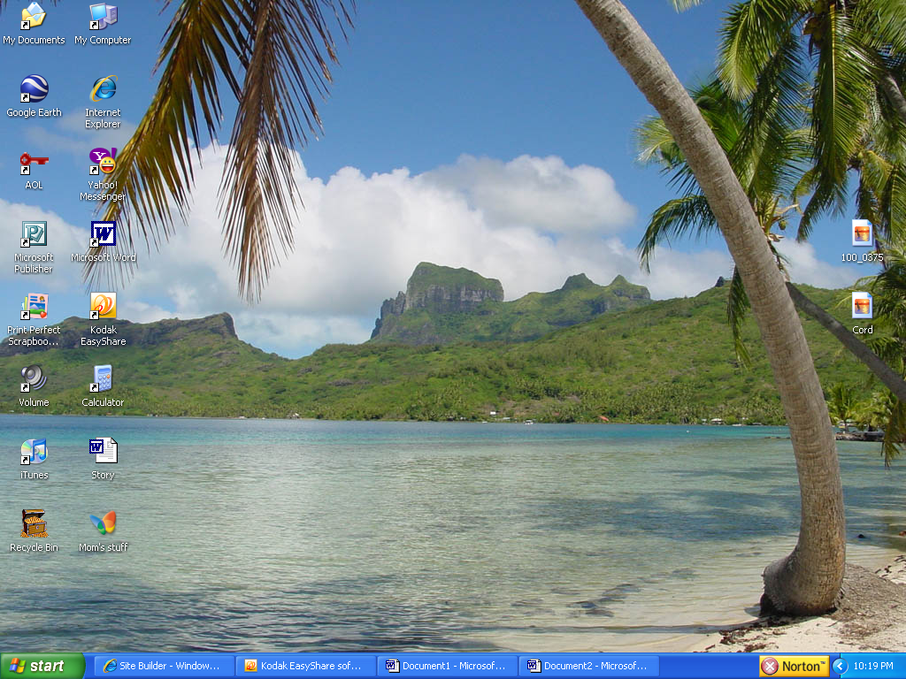
Step 7 – Click on the picture it self, and hold the mouse button down while you drag it over on to your desktop. Now let go. You should now have an icon on your desktop that looks something like this (with different numbers of course):

Go on to step 8 if you’d like to rename your picture, so you know what it is.

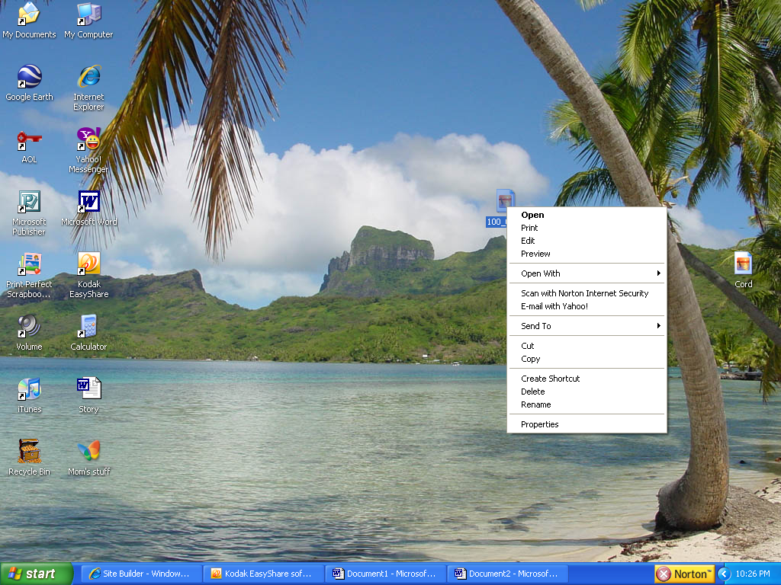
Step 8 – Right click on the icon of your picture, and select rename. Type away.

Notes – As for actually putting the pictures in the E-mails, there’s not much I can help you with there (because I’ve never seen your E-mail). But I believe what you did before was, after getting into your E-mail, and clicking on compose, you clicked on something like add attachment, and then browse, and then desktop, and then the name of the picture. I hope that helps.

Step 9 – (This is for after you have the pictures in the E-mails) If you want to delete the pictures from your desktop when you’re done, right click on the icon of your picture again and select delete. When it asks you if you want to send it to the recycle bin, say yes.
