Compressing Pictures
By: Brittany Clark

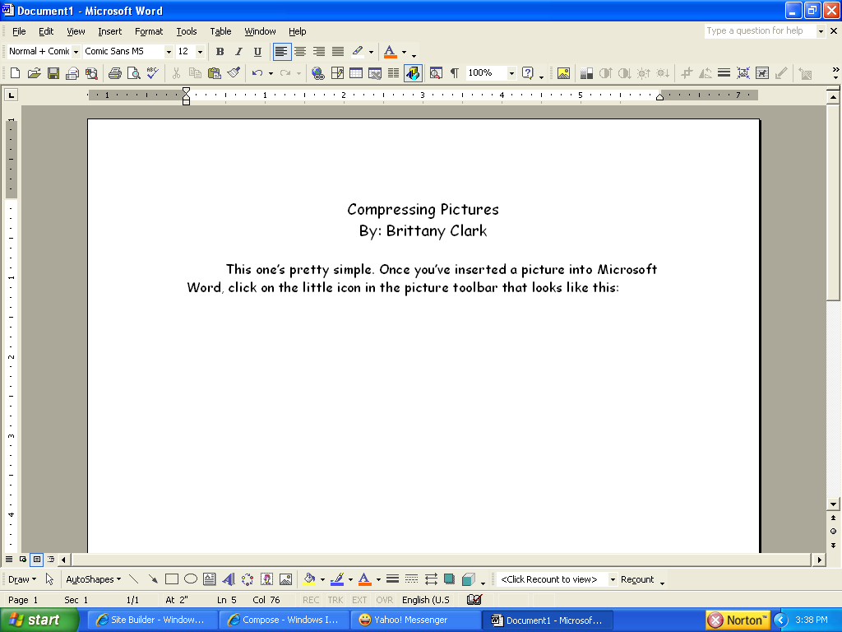
This one’s pretty simple. Once you’ve inserted a picture into Microsoft Word, click on the little icon in the picture toolbar that looks like this:

Then, a window will come up that looks like this:
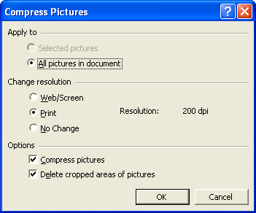

Make sure all the circled things are selected, and then click OK. Now, it doesn’t look like anything happened, but it really did. The pictures, even though they look the same are compressed down into less information, so that your E-mail service provider won’t yell at you when you try to send huge files! Of course, this isn’t foolproof. If you’re trying to send like 100 pictures, chances are the file will be too big anyway, and compressing the pictures still won’t let you send it. If that’s the case, first of all, I wonder why you’re trying to send 100 pictures, and secondly, my knowledge about sending pictures in word documents ends here.

